

Job Aid
What to do when SPAM gets through
Created: 21/09/2015
Name: Terry E Dow
Table of Contents
What Is It? 3
What Do I Have to Do? 3
1. When a suspect message is delivered to your Inbox 3
2. When a legitimate message is delivered to your Junk E-Mail folder 4
3. Review your Outlook Junk E-Mail Options 5
4. General guidance on preventing SPAM 6
What to Do if You Have Questions… 6

What to do when SPAM gets through

What Is It?
Unsolicited commercial email (UCE) also known as SPAM, viruses, malware and bulk email are being marked by our message hygiene solution and delivered to your Junk E-Mail folder. There are times when a new SPAM campaign is started that our message hygiene vendor has not yet identified. Once these messages are identified, the message hygiene filters automatically update and future similar messages should be marked as junk. There may be a brief window of opportunity that they are delivered to your Inbox until the process is complete.

What Do I Have to Do?

When a suspect message is delivered to your Inbox

  - Mark the message as junk by right-mouse clicking the (closed) message, select Junk and then select Block Sender.
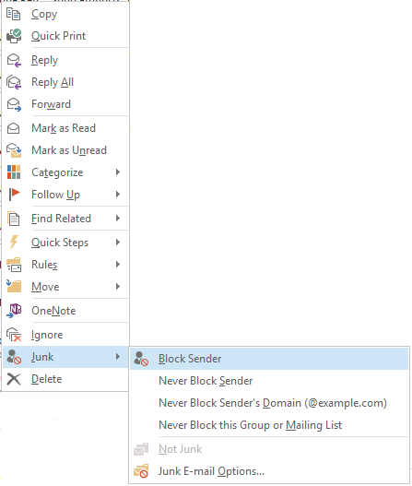
Similar messages in the future will be delivered to your Junk E-Mail folder. Messages in the Junk E-Mail folder are protected from invoking potentially risky contents when viewed. Messages in the Junk E-Mail folder are retained for 14 days and then are automatically deleted. Once deleted these messages no longer count against your mailbox storage quota limit and are recoverable by you for an additional 14 days.

  - Optionally forward the suspect SPAM as an attachment to junk@office365.microsoft.com. Sending a message to this address will provide our current message hygiene vendor a potentially new SPAM sample for their review. The correct method of forwarding the message is not to forward it directly, but to:
    - Open a new (blank) email,
    - Add the suspect message to the blank message as an attachment,
    - Address the blank message to junk@office365.microsoft.com,
    - Send it.

Any message not sent as an attachment will be ignored. Leave the message body of the new (blank) email empty.

When a legitimate message is delivered to your Junk E-Mail folder

  - Mark the message as not junk e-mail, by right-mouse clicking the (closed) message, select Junk and then select Not Junk.
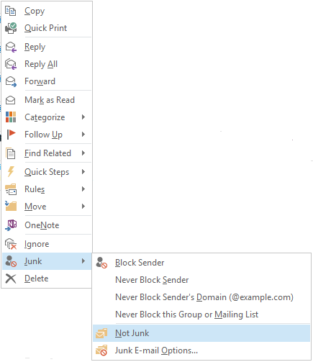

  - When the Mark as Not Junk popup window appears, select the OK button.
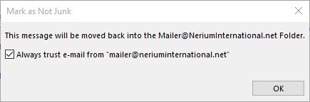

The message will be found in your Inbox. Similar messages in the future will be delivered to your Inbox. Messages in the Junk E-Mail folder are protected from invoking potentially risky contents when viewed, marking a message as not junk will remove that protection.

  - Optionally forward the legitimate message as an attachment to not_junk@office365.microsoft.com. Sending a message to this address will provide it to our current message hygiene vendor for their review. The correct method of forwarding the message is not to forward it directly, but to:
    - Open a new (blank) email,
    - Add the legitimate message to the blank message as an attachment,
    - Address the blank message to not_junk@office365.microsoft.com,
    - Send it.
Any message not sent as an attachment will be ignored. Leave the message body of the new (blank) email empty.

Review your Outlook Junk E-Mail Options
  - Select the Home tab
  - Select Junk pull down list
  - Select Junk E-mail Options…
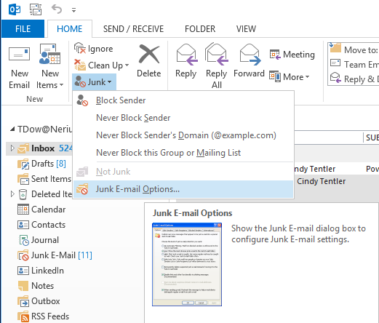

  - Select either the Low (recommended) or High protection setting.
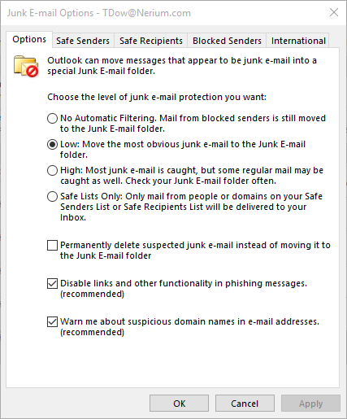

General guidance on preventing SPAM
  - Help keep spam out of your Inbox http://www.microsoft.com/security/online-privacy/spam-prevent.aspx
  - Overview of the Junk Email Filter https://support.office.com/en-us/article/overview-of-the-junk-email-filter-5ae3ea8e-cf41-4fa0-b02a-3b96e21de089
  - Fighting Junk Email https://mail.live.com/mail/junkemail.aspx

What to Do if You Have Questions…
If you are experiencing a problem, please submit a ticket via one of the following methods:
- Browse to: https://helpdesk.nerium.com
- Send email to: Helpdesk@nerium.com
- Call: +1(844)525-2007

Thank you,
Nerium Products and Technology Core Systems & Infrastructure

