Nerium International Code Red Support / Korea
Created: 11/6/2015

Revised Date: N/A

Nerium International Corporate Support / Korea
This process provides information outlining the support plan developed by Products & Technology (P&T) and Customer Support to improve the support process provided for the Nerium Korea team. This process also includes participation by the Nerium Tier 2 Support Team, and Korea Brand Center staff.

The following Process Flow Diagram and the Ticket Remediation Guidelines have been created to assist in your understanding of how issues are classified and supported by the Nerium International Infrastructure team members.

Process Flow Diagram
This process flow diagram is an overview of the process that is followed by the Nerium Corporate Infrastructure team. This will reflect resolving issues reported by the Nerium Korea Team. See figure below.
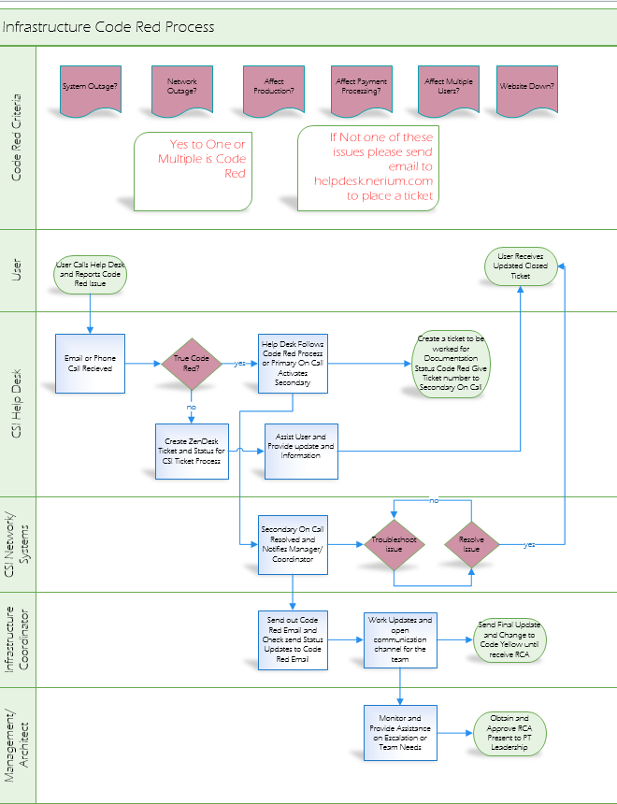

Nerium Ticket Remediation Guidelines
The Nerium P&T Infrastructure Teams are required to meet the following guidelines in order to show that user requests are being addressed in a timely fashion. The following tables list the issue severity type and the description of the issue that is defined within the Nerium Ticketing system for Desktop or Other Equipment issues, Network or Systems Related issues, and Application or Website Related issues.

Definitions: Types of Issues
- Web Site Issue
  - The issue is affecting customers or Brand Partners using our web sites.
  - Any issues with Exigo Admin for CSRs.
  - This will follow Corporate Support Korean Process
  - For Sev 1 Issues for Application Call Soojin
  - For Sev 2 Issues for Support Email tier2support@nerium.com and CC Soojin
  - EXAMPLES: NERIUM.KR shopping, enrollment, and back office.
  - For Website Code Red Issues they will be reported to correct PT Department. Call Help Desk and they will get correct On Call Support.
- Core Infrastructure Support Issue
  - The issue is affecting a technology that is NOT related to our web sites.
  - EXAMPLES: email, telephones, network, desktop computers, systems, or power
  - These are alerted by Solarwinds and StatusCake.
  - On Call staff monitors alerts and directs the course of action
  - They will activate primary when needed for additional troubleshooting and network or system support
  - Updates will be emailed to Code Red email group and global staff will receive communication updates as they occur
  - System issues will also be communicated through the CSI/DevOps or Quick Response Force Group on Skype
  - All Code Red Issues will be worked until the Issue is Resolved.

Definitions: Severity of Issues
- Code Red Issue: SEV1
  - The issue is affecting more than one customer, user, or Brand Partner.
  - The issue is affecting our ability to process payments or enrollments.
  - The issue is impacting a business process or business profitability.
  - The issue must be addressed immediately.
  - Network Outage
  - System Outage
  - Power Outage
  - Phone Outage
  - Emergency Status for Office/Brand Center/ Headquarters
  - Code Red Status : Code Red – Systems, Network, or Applications are down and need to be worked immediately until resolved
  - Code Yellow Status: Code Yellow: Functionality has been restored and are able for use but RCA is required and systems will be monitored to ensure that all has been resolved.
  - Code Green Status: Code Green: Stability has been restored and RCA has been received by Management
- Severity 2 Issue: SEV2
  - The issue is affecting only one user and/or does not require immediate assistance.
  - These issues will be work according to the Desktop/Network/Systems SLA Document

Updates
Updates on deliverables for Code Red Infrastructure Issues will be provided by Infrastructure Coordinator or Management.
Contact Chuck Ball, Hiroki Yoshikawa or Jana Gilmore to ensure updates are communicated to PT Leadership and Executives.

Severity Types for Desktop or Other Equipment Related Issues
ISSUE SEVERITY TYPE | ISSUE DESCRIPTION
Sev1/ Urgent | To issue this type of ticket, the user’s PC or equipment must be completely non-functioning AND preventing the user from performing their job function.
Urgent/Urgent | Use this type of ticket for Executive users or tickets the Support management requests
Urgent/Printers | Use this type of ticket for all printer-related issues
High/ Add/Change | Use this type of ticket to Add or Change permissions or Install New Software.  - The ticket’s status will change to “on hold” status should software or hardware need to be ordered.  - The ticket’s status will change back to “open” status once order has been received.
Medium/ Maintenance | Use this type of ticket for computer issues [something goes wrong with computer] or Connectivity Issues with the Network.  - If new hardware or software is required the ticket will follow the Severity 4 process.
Low/Maintenance | Use this type of ticket for Issues that do not prevent the user’s ability to continue their job function.
Low/IMAC/Equipment Replacement | Use this type of ticket for Replacement of existing equipment  - Product service ended  - Product upgrade is required and it does not impact the user’s ability to perform their job function.
Low/IMAC/PC Setup | Use this type of ticket for to Setup a computer [PC] or other equipment for new members of Nerium Staff.
Low/IMAC/PC Move | Use this type of ticket for to Move a computer or other equipment to a different location. For example, move equipment to a new desk or work area.
Low/IMAC/PC Swap | Use this type of ticket for to exchange a computer with another computer.  This ticket type must be completed with Data Transfer and PC Move Definitions.

Severity Types for Network or Systems Related Issues
ISSUE SEVERITY TYPE | ISSUE DESCRIPTION
Code Red/Sev 1/ Urgent | Use this type of ticket for Emergency Request [Code Red] that must be worked immediately and completed immediately
Sev2/High( Break/Fix) | Use this type of ticket for Tickets affecting production - High Priority Request
Change Management | Use this type of ticket for See Change Management Process for Required Approvals and Time Frame. Approvals for Change Management are set by the Change Action Board.  - Add new phone line OR  - Any change to the existing infrastructure, server or network environment
New Service | Use this type of ticket for New Service Request from Business or P&T- New Equipment Installation and Implementation
Maintenance | Use this type of ticket for Service Request on Existing Implemented Service
Maintenance /Standard Scheduled | Use this type of ticket for Standard Scheduled Maintenance Monthly Tickets
Maintenance/Non Scheduled/Proactive | Use this type of ticket for Non Scheduled and Proactive Maintenance
Project | Use this type of ticket for any project effort for the infrastructure team.  - Requests for over 6 Computer moves or adds or changes  - Request for over 10 new service or existing service changes  - New technology implementations

Severity Types for Application or Website Related Issues
ISSUE SEVERITY TYPE | ISSUE DESCRIPTION
Sev1 / Urgent | Use this type of ticket for Emergency Request [Code Red] that must be worked immediately and completed immediately.  - http://nerium.kr/ is not functioning  - Follow Corporate Support/Korea Process
Sev2 / High | Use this type of ticket for Tickets affecting production, a defect.  - Application is unable to process orders  - Application is unable to charge credit cards  - Application is unable to access the back office
Sev 3 / Medium (Hot Fix) | Use this type of ticket for Hot Fixes or other immediate changes that are required for the Application Environment. See the Change Management Process for the Required Approvals and Time Frame for implementation.
Sev 4 / Low (Feature Request) | Use this type of ticket for a New application enhancement Request from Stakeholders or one of the Products &Technology teams. The Timeline to be determined by the Stakeholder, Delivery Team, Production Support or P&T Leadership.  - Add a new feature or functionality to the Application  - Timeline to be defined by the Business or Project Management
Coding Request | Use this type of ticket for Service Request on Existing or Implemented software or other system components.
Repair | Use this type of ticket for Standard Scheduled Maintenance that is typically scheduled on a bi-weekly or monthly basis.
Service Request | Use this type of ticket for Non Standard/ Non Scheduled/Proactive Maintenance of the existing software or other system components.
Project | Use this ticket for requested project work. The Timeline to be defined by the Stakeholder, Delivery Team, Production Support or P&T Leadership.

Nerium Corporate Support Contact List
The following tables contain the contact information for the leadership teams of the Products & Technology (P&T) and the Infrastructure Leadership Support teams located at Nerium Corporate Headquarters. These numbers are provided as additional contact information, but you should always use the contact information listed in the Process Diagram when reporting your issue.
Products and Technology (P&T) Leadership:
Name | Title | Phone | E-mail
Ana Clark | Chief Information Officer (CIO) | 817.991.2355 | aclark@nerium.com
Ryan Bovermann | VP, Products & Technology | 214.690.0756 | rbovermann@nerium.com
Christopher Bauer | Director, Product Delivery | 972.998.8141 | cbauer@nerium.com
Heather Crumley | Program Manager, Portfolio Management | 214.673.0795 | hcrumley@nerium.com
Paul Eaklor | Enterprise Architect | 214.435.2353 | peaklor@nerium.com
Yamil Pedrozo | Solutions Architect | 954.547.0587 | yamil@nerium.com
Ed Ponce | Delivery Manager, Production Support | 214.228.1479 | eponce@nerium.com
Chuck Ball | Senior Manager, Infrastructure | 214.504.4229 | cball@nerium.com
Mauricio Hernandez | Manager, Application Development |  | mhernandez@nerium.com
Adam Rogers | Manager, Quality Assurance | 512.663.4999 | arogers@nerium.com

Core Systems Infrastructure Leadership:
Name | Title | Phone | E-mail
Hiroki Yoshikawa | IT Director, APAC |  | hyoshikawa@nerium.com
Mike Gronholz | Infrastructure Architect | 214.382.9352 | mgronholz@nerium.com
Jay Allen | Lead, Systems Administrator and Network | 214.636.5130 | jallen@nerium.com
David Sinclair | Lead, Help Desk and Desktop Administrator | 214.960.3010 | dsinclair@nerium.com
Jana Gilmore | Infrastructure Coordinator | 940.704.4656 | jgilmore@nerium.com

