Nerium International CSI Lifesize Job Aide

Revised Date: 11/11/2015

Jana Gilmore Infrastructure Coordinator, CSI

Nerium International CSI Lifesize Conferencing Job Aide
This process provides information outlining the support plan developed by Products & Technology (P&T) and Core Systems and Infrastructure support process provided for support of Teleconferencing System Lifesize.

- Using the Lifesize Teleconferencing System can help to reduce international calling and allow for meetings with anyone in the Nerium Organization with a Lifesize account.
- You can log into Lifesize app on your phone or computer and speak with any Lifesize account.
  - https://manage.lifesizecloud.com/#/download is the link for downloading the account to your phone or PC.
  - 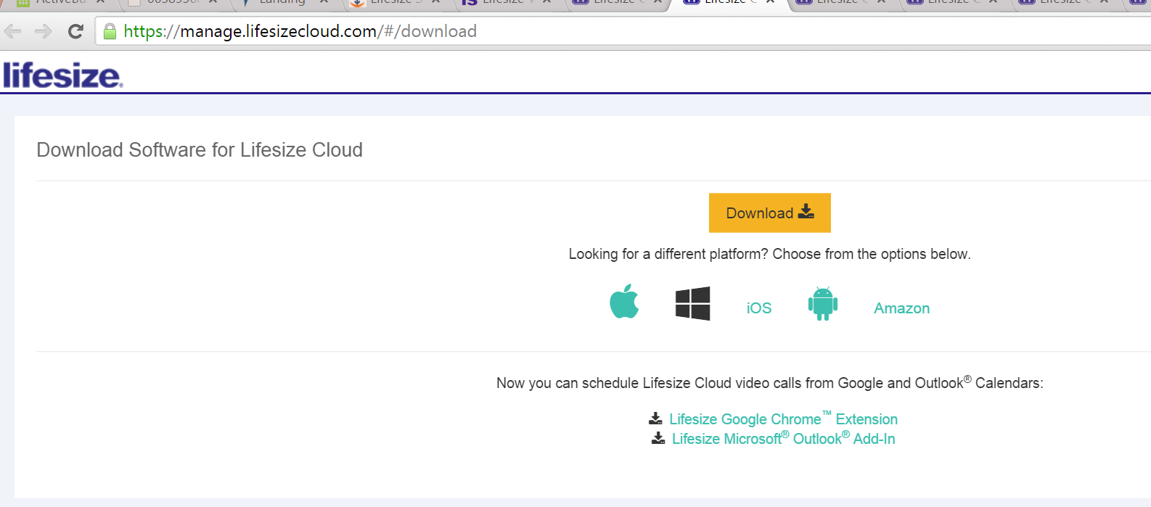
  - Lifesize Cloud can also be downloaded to your phone through Google Play or Apple Store.
  - For Korea we have the Nerium Korea Account, The Korea Account and BJ Choi
    - If another account is needed please place CSI ticket and an account can be created for use.
- For More Training Videos Please see https://www.lifesize.com/en/services/education-services
- Users can also give dial up number for users so that they can join the meeting from phone, pc or conference room with Lifesize guest account.
  - You can send email to the user that will have Connection String and they can dial into the meeting

Phone App Use
  - 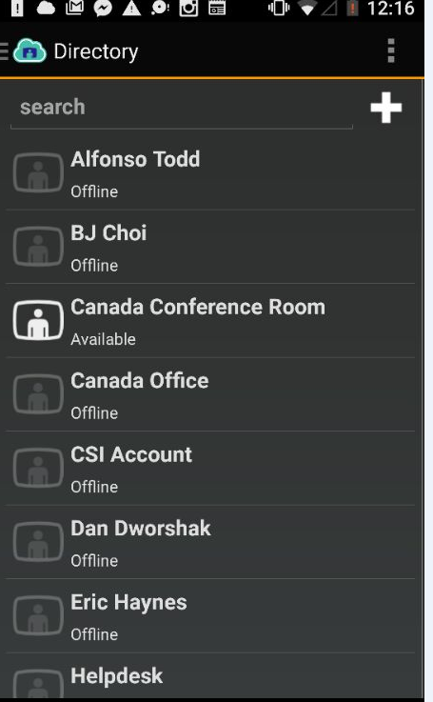 This screen has the Company Directory of all Lifesize Users

  - 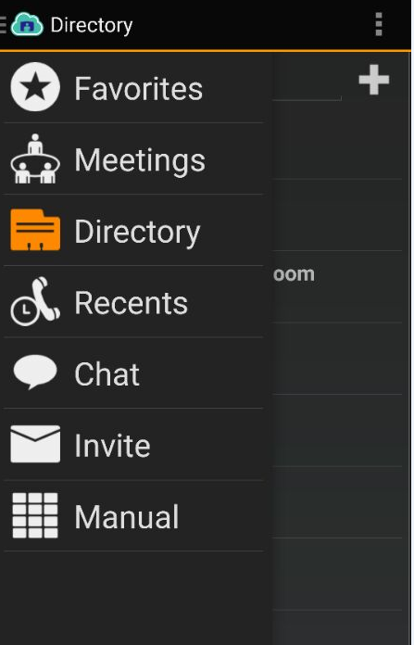 Main Menu Screen
- 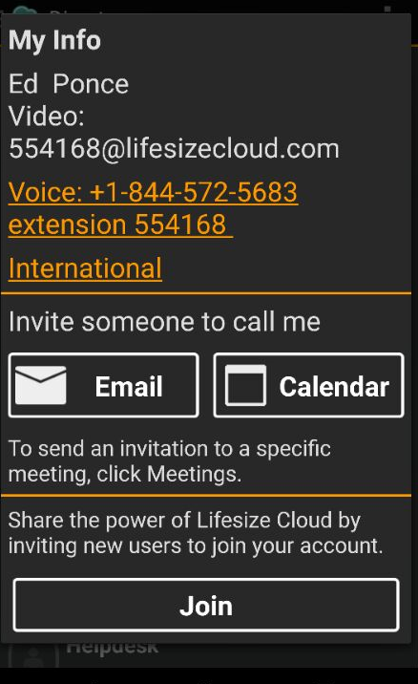You can invite someone to call or join as guest user.

- Lifesize has the ability to record meetings and set reoccurring meetings that can be dialed into and can be accessed from anywhere. Here is example of the current meeting that are being used.

- You can call from HQ Conference Room to Brand Center Conference Room as well. All meetings can be joined or recorded.
- 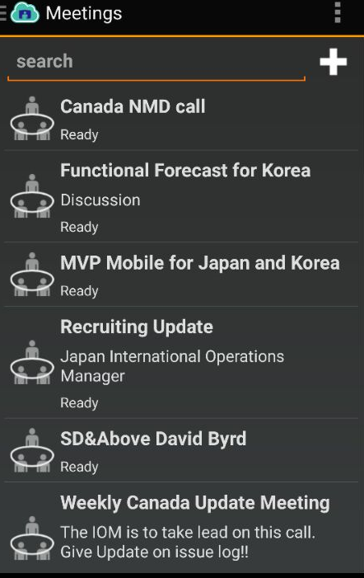 Examples of Current Meetings

LifeSize Video Icon System