

Job Aid
Mailbox Storage Quota Limits
Created: 10/14/2015
Name: Terry E Dow

Table of Contents
1. What Is It? 3
2. When Is It Happening? 3
3. What Do I Have to Do? 3
3.1. Do’s: 4
3.2. Don’ts: 4
4. What to Do if You Have Questions… 4
5. How To’s 6
5.1. How to use the Outlook Clean Up tool 6
5.2. How to use the Mailbox Cleanup tool 6
5.3. How to add a column to a folder view 7
5.4. How to remove attachments from a message 8
5.5. How to view your Calendar as a list 8
5.6. How to use AutoArchive to delete old messages 9
5.6.1. Global setting: 9
5.6.2. Per folder setting: 10
6. References 12

What Is It?
We are implementing mailbox storage quota limits on all mailboxes.

The default mailbox storage quota limit is 2GB. This will have no effect on the majority of mailboxes.

- Once you’ve gone past 1.9GB you may begin to receive a warning message.
- Once you’ve gone past 2GB you will not be able to send any message until after you’ve removed enough (remember to empty your Deleted Items folder) to put you under 2GB.
- Once you’ve gone past 2.3GB you will not be able to send or receive messages – messages sent to you will be return to the sender stating that your mailbox is full.

For those mailboxes at or over 2GB we have temporarily increased your limit.

When Outlook client is started there are specific folders (Inbox, Calendar, Tasks, Sent Items, and Deleted Items) that are opened first. If one or more of these have a large number of items then Outlook will take much longer and more resources to start, resources in your Outlook client, mobile device and Outlook Web App. Anyone you share your mail folders with will also experience this. It is in yours and your workgroup’s best interest to keep the number of messages you retain as few as needed. Keep the number of message coming into our mailboxes at or below the number of messages that are deleted. Keeping the ones that still have importance and deleting the ones which importance has past to increase the quality of the retained messages.

Mailboxes that consume an excessive amount of storage space place a burden on the email servers and put their operation at risk. The email servers have sufficient but finite capacity. Large mailboxes slow down the server, so that not only do you experience reduced performance, you are also reducing the performance for all others. Please be considerate of this community resource.

We have implemented two solutions to help you maintain your mailbox size:
- Your Junk E-Mail folder automatically deletes messages over 14 days old.
- Your Deleted Items folder automatically deletes messages over 30 days old.
Once deleted they no longer count against your mailbox storage quota limit. You can recover these deleted messages for an additional 14 days from your recoverable deleted item container.

When Is It Happening?
Oct 7th 2015.

What Do I Have to Do?
In one hour most of your unneeded email could be cleaned out. 5-10 minutes a week and you can maintain your mailbox size.

Everyone’s use and habits with Outlook is different, so there is no single method to cleaning out old messages. The goal is not to simply delete messages older than X days, the goal is to delete messages that are no longer needed. The following are some recommendations.

Do’s:
Use the Outlook Clean Up tool (see 5.1) to remove redundant messages. Outlook can group messages by subject into Conversations (select View tab, enable Show as Conversation check box). As a conversation continues, many of the newer message may contain the former messages. This tool will confirm the former messages are contained in the newer ones, and then delete the former redundant messages.

Use the Mailbox Cleanup tool (see 5.2) to find large messages. Sort messages by the Size column to identify large messages. If you have already saved an attachment, remove the message or at least remove the attachment from the message (see 5.4).

Temporarily sort messages by the From column. Walk through the folder and look for messages being sent by a particular sender that has short term value such as alerts, notification, solicited commercial email, subscriptions and newsletters. Look for senders that frequently send large messages. Similarly sort message by the Subject column and review.

Temporarily view your Calendar folder as a list (see 5.5) and sort by the Size column (see 5.3) to identify large calendar items with attachments which can be removed.

Use Auto-Archive (see 5.6) to delete messages in particular folders after a certain age. Most messages after 15 months (one and a quarter years) are rarely accessed. If you have rules to move messages to folders, you can apply the Auto-Archive setting to that folder to delete messages older than some date.

Don’ts:
Instead of sending messages with large attachments, when practical consider placing the intended attachments in a location that all the recipients can access, and insert a reference to the location in the message.

Do not attach large content in a meeting request. The attachments may stay in your and each attendees Calendar folder for an extended time.

Do not archive your messages to a Personal Folder or Archive Folder (PST files). PST files are only available on the workstation they were created on. They are not searchable or accessible from your mobile device, Outlook Web App, or from any other workstation. Your workstation is not backed up. If it were to have an issue, those PST files may be lost.

What to Do if You Have Questions…
If you are experiencing a problem, please submit a ticket via one of the following methods:
- Browse to: https://helpdesk.nerium.com
- Send email to: Helpdesk@nerium.com
- Call: +1(844)525-2007

Thank you,
Nerium Products and Technology Core Systems & Infrastructure

How To’s

How to use the Outlook Clean Up tool
Remove redundant messages
    - On the Home tab, in the Delete group, select Clean Up.
    - Select one of the following:
      - Clean Up Conversation The current Conversation is reviewed, and redundant messages are deleted.
      - Clean Up Folder All Conversations in the selected folder are reviewed, and redundant messages are deleted.
      - Clean Up Folder & Subfolders (recommended) All Conversations in the selected folder and any folder that it contains are reviewed, and redundant messages are deleted.

How to use the Mailbox Cleanup tool
    - Select the File tab
    - Select Cleanup Tools pull down list, and then select Mailbox Cleanup
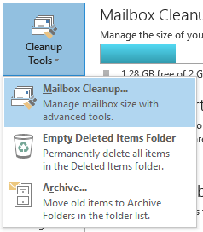

    - Select the View Mailbox Size… button to prioritize which folders need the most attention.
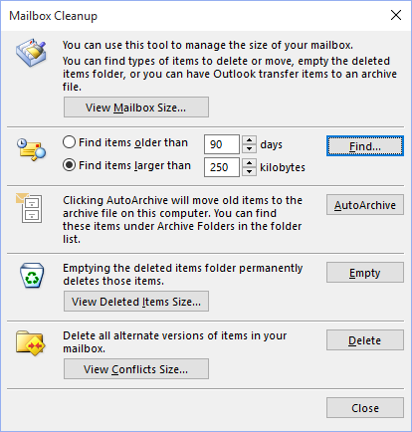
    - Select the Find… button to view all large messages or all old messages. Sort on the Size column to identify the largest messages.

How to add a column to a folder view
    - Select the View tab,
    - In the Current View group, select View Settings.
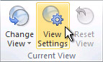
    - In the Advanced View Settings dialog box, select Columns.
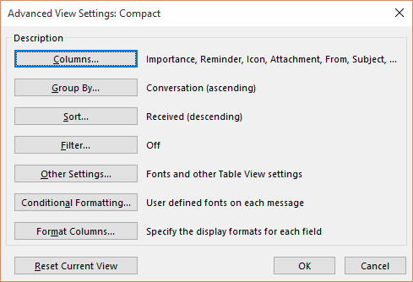
    - In the Show Columns dialog box, in the Available columns list, select a column name (such as Size), and then select the Add -> button.
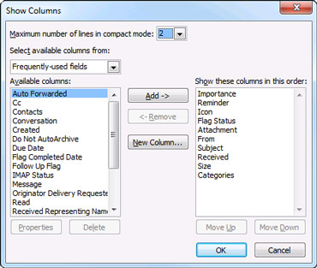
If the column that you want is not in the Available columns list, select the Select available columns from box to see additional sets of columns.
To remove a column, in the Show these columns in this order list, select a column name, and then select the <-Remove button.

How to remove attachments from a message
    - Open a message that has an attachment.
    - Right-mouse click the message’s attachment tab
    - Select Remove Attachment.
    - Close the message.
    - Select the Yes button to save the message without the attachment.
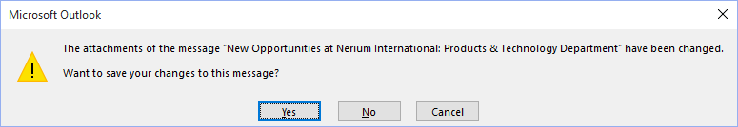

How to view your Calendar as a list
    - Select the Calendar folder
    - Select the View tab
    - Select the Change View button in the Current View group
    - Select List
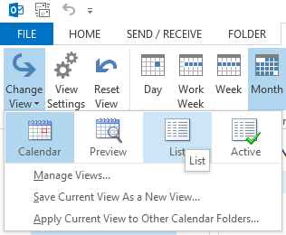
To restore the view…
    - Select the View tab
    - Select the Change View button in the Current View group
    - Select Calendar

How to use AutoArchive to delete old messages
There are two settings for Auto-Archive. One sets the global setting for AutoArchive. It defines how often to run, and what default action to perform. The second is a per folder AutoArchive setting. This is where you should define what action to perform for this folder.

Global setting:
      - Select File tab
      - Select Options (left pane)
      - Select Advanced (left pane of the Outlook Options pop up window)
      - Select AutoArchive Settings… button
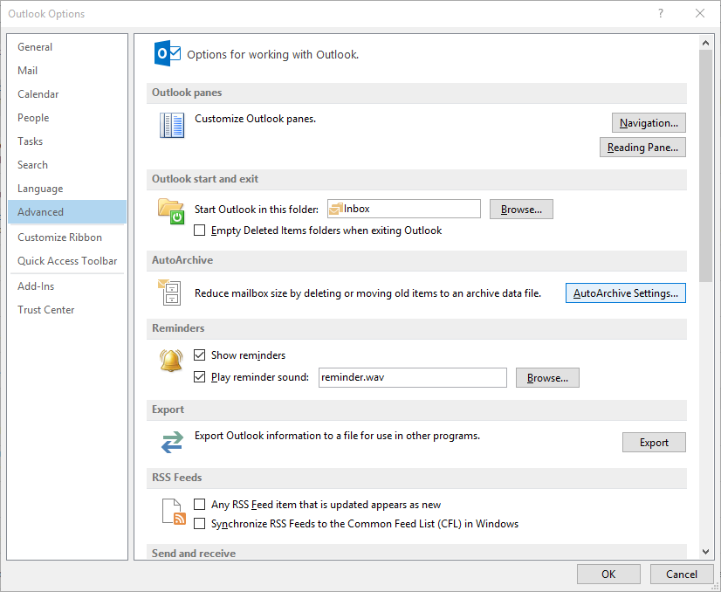
      - Change the settings to run every 14 days, but DO NOT set it to delete or archive at the global setting level. Failure to do this may remove all old messages.
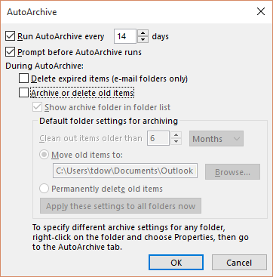

Per folder setting:
      - Select a folder which collects messages that only have short term value such as alerts, notification, solicited commercial email, subscriptions and newsletters.
      - Right-mouse click the folder and then select Properties.
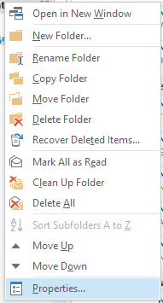
      - Select the folders AutoArchive tab.
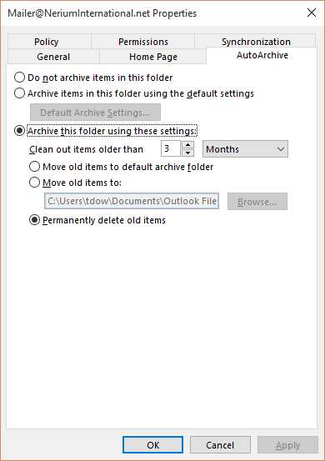
      - Set the age limit for items in this folder.
      - Set the action to permanently delete old items.
      - Select the OK button.
Repeat this for any other folder with short term value content.

References
  - Outlook performance issues when there are too many items or folders in a Cached mode .ost or .pst file folder https://support.microsoft.com/en-us/kb/2768656
  - Manage my mailbox size https://support.office.com/en-us/article/Manage-my-mailbox-size-792b521c-3f4e-404e-b436-9c197bad6f45
  - Reduce the size of Outlook data files https://support.office.com/en-us/article/Reduce-the-size-of-Outlook-data-files-E5E846CD-CFF1-4F53-A95D-5E094E4B032B
  - Use Conversation Clean Up to delete redundant messages https://support.office.com/en-us/article/Use-Conversation-Clean-Up-to-delete-redundant-messages-70179D54-FA57-48CE-95FD-416D72E5CCD4
  - Webinar: 5 simple ways to clean up Outlook https://blogs.office.com/2014/06/09/office-15-minute-webinar-5-simple-ways-clean-up-outlook/
  - Removing Large Attachments from Email in Outlook 2010 https://www.youtube.com/watch?v=aGYj1V2E4Ng
  - Microsoft Outlook 2013: Mailbox Cleanup https://www.youtube.com/watch?v=8oDBPk3278k
  - Add or remove columns in the Inbox https://support.office.com/en-us/article/Add-or-remove-columns-in-the-Inbox-78098e3e-8203-47da-815e-cb66f76b512e

